EXERCISES
PART 5: Evaluations

These exercises accompany part 5 of The Stories We Live By: an online course in ecolinguistics.

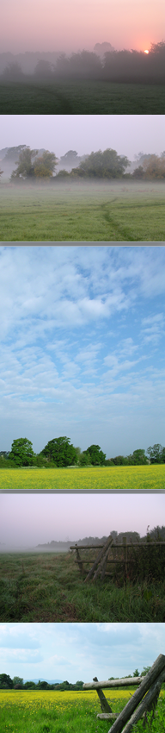
Exercise 1
This question is based on extracts from the BBC Points West weather forecast in the UK. Please analyse these in terms of the appraisal patterns: what kinds of words, phrases and expressions are used to evaluate the weather? Which types of weather are represented positively and which negatively? What does this say about the cultural stories of the weather that underlie the forecasts? You can represent the results graphically in any form, e.g., mind map, brainstorm, comic format.

1. DATA: Extracts from BBC Points West weather forecast, UK
- Saturday looks to be rather wet and windy first thing but improving through the weekend and brightening up as we get to Sunday
- from daybreak most of you will see a great improvement taking place leading us into what will be effectively a dry and largely sunny day
- in Somerset you may be stuck under this veil of cloud
- we continue this risk of showers and more persistent spells of rain
- For a time today there was some sunshine around and it was very pleasant
- the rain creeping in from the west, but it is then an improving picture
- the showers won’t linger over any one spot
- there will be widespread sunshine albeit tempered by some high cloud
- the edge of that cloud has lingered over parts of east Wiltshire
- No threat of any rain…it should be a decent start tomorrow morning
- Hopefully some sunny spells, maybe a sneaky shower or two but I expect the best of the brightness will emerge on Saturday
- outbreaks of light and patchy rain creeping in through the morning
- once we get rid of any morning showers a good chunk of the day will be dry.
- Again, there will be some very pleasant spells of sunshine until another band of rain starts to make its presence felt
- A rash of showers developing towards the afternoon
- The cloud broke up very well indeed.
- We have seen more lovely weather so far today but into the afternoon I think we will see more cloud developing
- it may be that we have an invasion of cloud from the east

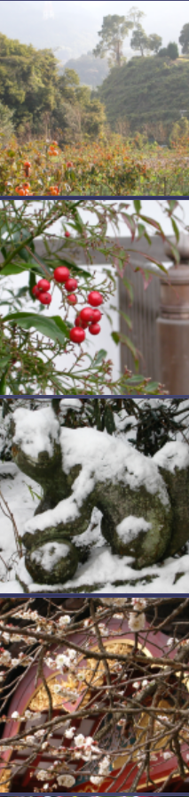
Exercise 2

Conduct a similar analysis of the data below, which consists of selected Japanese nature haiku. How are the underlying stories about the weather in the haiku poems different from the UK weather forecast? What implications might there be for how people interact with nature and fulfil their needs?

2. DATA: Selected Japanese haiku poems
- Becoming a cow / would be fine, morning naps / the evening cool. Shiko
- Joyful at night / tranquil during the day / spring rain. Chora
- Evening breeze / the white roses / all sway. Shiki
- Summer coolness / lantern extinguished / the sound of water. Shiki
- Sudden evening shower / rising from the heat / broken-down horse. Kito
- Hollyhocks follow / the slanting path of the sun / in summer rains. Basho
- What fun / it may change into snow / the winter rain. Basho
- What heat today! / I blow the dust / from a rock. Onitsura
- So hot / even rocks and trees / shine in my eyes. Kyorai
- Spring is here / morning mist / on a nameless mountain. Basho
- Evening joy / noontime silence / spring rain. Chora
- Owning nothing / such peace / such coolness! Issa
- Traces of school ink / on his lips, a child enjoys / the evening cool. Senna
- Spring rain / a child teaches its cat / to dance. Issa
- Spring rain / visible through the trees / a path to the sea. Otsuni
- Summer rains / secretly one evening / moon in the pines. Ryota
- Whatever she wears / she becomes beautiful / moon-viewing. Chiyo
- Sudden shower / a woman looking out / alone. Otsuyu
- Passing spring / a white flower visible / through the fence. Buson
- Early summer rain / running through the gutters / old man’s music. Buson
- Blazing sun / whose barefoot child / is running free? Koyo
- Sculpting the shape / of the plum tree / first winter rain. Kito
- In the large room / one person / and one fly. Issa
- Calling three times / then no more to be heard / deer in the rain. Buson

Exercise 3

From an ecological perspective, what problems or issues might there be with the following evaluations: fast is good, more is good, big is good, convenient is good, progress is good, and growth is good?

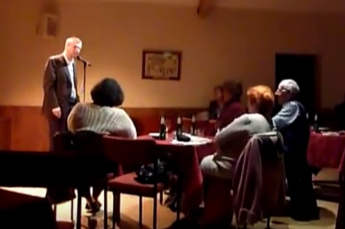
Exercise 4

Discuss how the poet Matt Harvey resists the common cultural evaluations of more is good and less is bad in his poem Less is More, below:

4: Data: Less is More by Matt Harvey
Can less be more, can more be less?  Well, yes and no, and no and yes  Well, more or less…  More bikes, fewer cars  Less haze, more stars  Less haste, more time  Less reason, more rhyme  More time, less stress  Fewer miles, more fresh (vegetables)  Fewer car parks, more acres of available urban soil  More farmers’ markets, less produce effectively marinated in crude oil  Less colouring, more taste  More mashing, less waste  Fewer couch potatoes, more spring greens  Fewer tired tomatoes, more runner beans  More stillness, less inertia  Less illness, more Echinacea  More community, less isolation  Less just sitting there, more participation!  More wells (not oil ones, obviously), fewer ills  Fewer clean fingernails, more skills |  | More co-operation, less compliancy  Less complacency, more self-reliancy  Less competition, more collaboration  Less passive listening, more participation!  Less attention defic…, more concentration  Less passive listening, more participation!  (Less repetition)  Less of a warm globe, more a chilly’un  More of a wise world, at least 34 fewer parts of C02 per million  Less stress-related cardio-vascular and pulmonary failure  More nurturing quality time in the company of a favourite clematis or dahlia  More craftsmanship, less built-in obsolescence  More political maturity, less apparently-consequence-free extended adolescence  More believed-to-be-beautiful, known-to-be-useful things  Less cheap, pointless, petroleum-steeped stuff  So Yes, less is more – and enough’s enough…

Further Reading

These exercises are based on examples discussed in chapter 5 of Ecolinguistics: language, ecology and the stories we live by (Arran Stibbe, 2015, Routledge).

Share what you discovered

If you would like to share insights you discovered through these exercises then you can register for the free online course Stories We Live By here: http://storiesweliveby.org.uk/register. You will then have access to discussion groups, pages you can edit, and can apply for a free certificate of completion.

References

Weather forecast data taken from a corpus of transcripts of the video weather forecast from Points West, BBC. http://www.bbc.co.uk/weather/2653261

Haiku poetry from:

Addiss, S. and Yamamoto, F., 2002. Haiku landscapes: in sun, wind, rain, and snow. Boston: Weatherhill.
Addiss, S., Yamamoto, F., and Yamamoto, A., 1996. A haiku garden: the four seasons in poems and prints. Boston: Weatherhill.
Addiss, S., Yamamoto, F., and Yamamoto, A., 1998. Haiku people, big and small: in poems and prints. Boston: Weatherhill.
Lanoue, David. (2016) Haiku of Kobayashi Issa. http://haikuguy.com/issa/
Yamamoto, A., 2006. A haiku menagerie: living creatures in poems and prints. Boston: Shambhala.

Matt Harvey's poem Less is More was first published in Issue 258 of Resurgence & Ecologist: http://www.resurgence.org. Reproduced with permission from Matt Harvey and The Ecologist.

Photographs from:
Stibbe, Arran (2016) Living in the Weatherworld. Available from www.intheweatherworld.wordpress.com

