EXERCISES
PART 8: Erasure

What to look for

Hypernyms, e.g. birds, mammals, fish, species, organisms, flora, fauna

Abstractions, e.g. biodiversity, ecosystem

Metaphors, e.g. terrestrial resources, natural capital, harvesting chickens

Indirect Associations, e.g. living and physical environment, wetland habitat

Functionalisation, e.g. primary producers, dispersers, pollinating insects

Mass Nouns, e.g. biomass, wood, 27 tonnes of biomass imports

Grammatical Embedding, e.g. fish consumption, bird capture

Passivation, e.g. the farmers euthanized the piglets

Morphological Embedding, e.g. fisheries
These exercises accompany part 8 of The Stories We Live By: an online course in ecolinguistics.

Exercise 1

The Millennium Ecosystem Assessment “recognizes that the actions people take that influence ecosystems result not just from concern about human wellbeing but from considerations of the intrinsic value of species and ecosystems. Intrinsic value is the value of something in and for itself, irrespective of its utility for someone else” (MA:9). Below are some examples of how the Millennium Ecosystem assessment represents fish. Do these examples encourage respect for fish as living beings with intrinsic value? Or do they use linguistic features in a way that erases fish?

1. DATA: from Millennium Ecosystem Assessment
Algal blooms in coastal waters are increasing in frequency and intensity, harming other marine resources such as fisheries as well as human health. (MA:20)
Currently, one quarter of marine fish stocks are overexploited or significantly depleted. (MA:82)
The fish being harvested are increasingly coming from the less valuable lower trophic levels as populations of higher trophic level species are depleted (MA:29)
Trade in commodities such as grain, fish, and timber... (MA:94)
Toxic chemicals produced by some blue-green algae during blooms keep people from swimming, boating, and otherwise enjoying the aesthetic value of lakes (MA:119)
African mammals, birds in agricultural lands, British butterflies, Caribbean corals, and fishery species show the majority of species to be declining in range or number. (MA:59)
The loss of an important fish nursery area in a coastal wetland may diminish fish catch some distance away. (MA:23)
In some marine systems fish biomass targeted in fisheries has been reduced (MA:29)
A deterioration of the services provided by freshwater resources such as aquatic habitat, fish production, and water supply for households (MA:30)
These impacts include toxic algae blooms, other human health problems, fish kills, and damage to habitats such as coral reefs. (MA: 125)
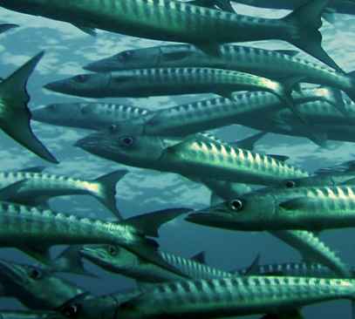
If people think of fish as objects with no value beyond human consumption, then how might this influence how they treat other animals and the environment? What kinds of language would be better at representing fish, other animals and the environment in ways which inspire people to care and protect them?

Exercise 2

Compare the pairs of examples below in terms of the extent to which they erase animals. Think about how the texts create (or fail to create) vivid images of the animals in the minds of the reader, and the linguistic devices which contribute to this.

2. DATA: pair 1
The rapid loss of species we are seeing today is estimated by experts to be between 1,000 and 10,000 times higher than the natural extinction rate. These experts calculate that between 0.01 and 0.1% of all species will become extinct each year (WWF, EN18)
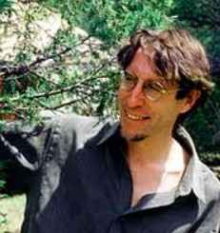
Massive animals and small animals, hoofed ones and clawed ones, antlered and quilled and bright-feathered ones, finned and tentacled and barnacled ones, all steadily dwindling down to a few members before they dissolve entirely into the fever dreams of memory (David Abram, 1996)

2. DATA: pair 2
The Gloucestershire Old Spot is a large meaty animal with a broad and deep body and large hams. Its white coat has large clearly defined black spots (Breeders association, AG5).
We have two Boars - Pumba and Naughty Nigel. Pumba is a gentle giant, and loves his ears being scratched, but don't get between him and his food! Nigel is slightly shy, although not when it comes to his wives! (Harmony herd, AG4).

2. DATA: pair 3
In the United States, more than 7 billion chickens are killed for their flesh each year, and 452 million hens are used for their eggs…At the slaughterhouse, their legs are forced into shackles, their throats are cut, and they are immersed in scalding-hot water (PETA, EN19).
Chickens would naturally spend their day foraging for food, scratching the ground looking for insects and seeds. When a cockerel finds food, he may call the hens to eat it by clucking in a high pitch and picking up and dropping the food. This behaviour can also be seen in mother hens, calling their chicks (Compassion in world farming, EN20).

Exercise 3

There are three main types of erasure: the void, where something of importance is not mentioned at all, the trace, where it is mentioned indirectly, and the mask, where it is described in a distorted way. Firstly, gather together some texts which describe plants, animals or the environment. They could be texts on zoo websites, environmental reports, biology textbooks, or children’s books. Next analyse the texts looking for examples of erasure. Say whether the examples are void, trace or mask, and what linguistic devices are used in the erasure.

Exercise 4

Images can also cause erasure, for example by failing to represent a subject at all; representing the subject in a small size or in the corner of a frame; showing them as part of a large group rather than as an individual; looking down at the subject (which makes them seem powerless); representing them as blurred or partially concealed, representing them in a stylised or distorted way, or as inactive (i.e., not doing anything).

Please consider the images below. What visual devices in the picture erase the plants or animals?

1.
2.
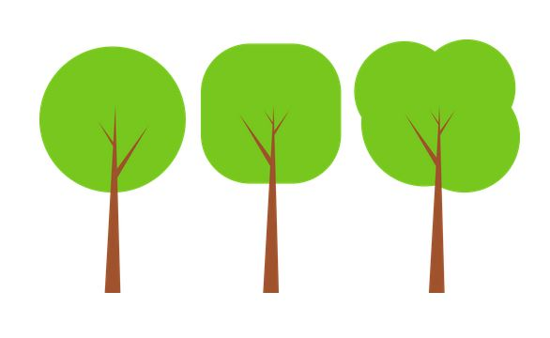
Openclipart. https://openclipart.org

3.
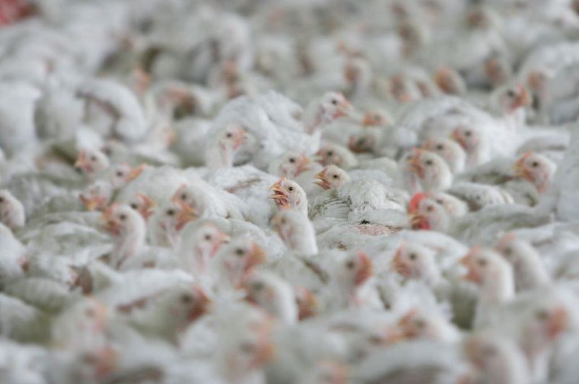
Courtesy of Compassion in World Farming
4.
5.
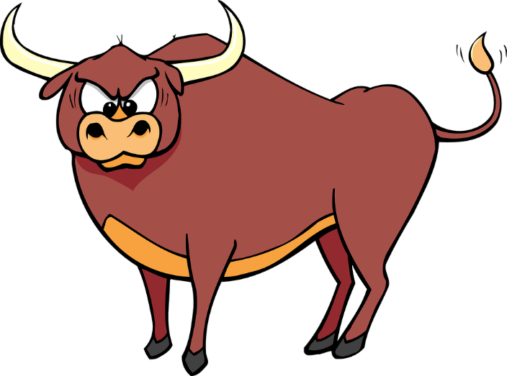
Openclipart. https://openclipart.org

7.
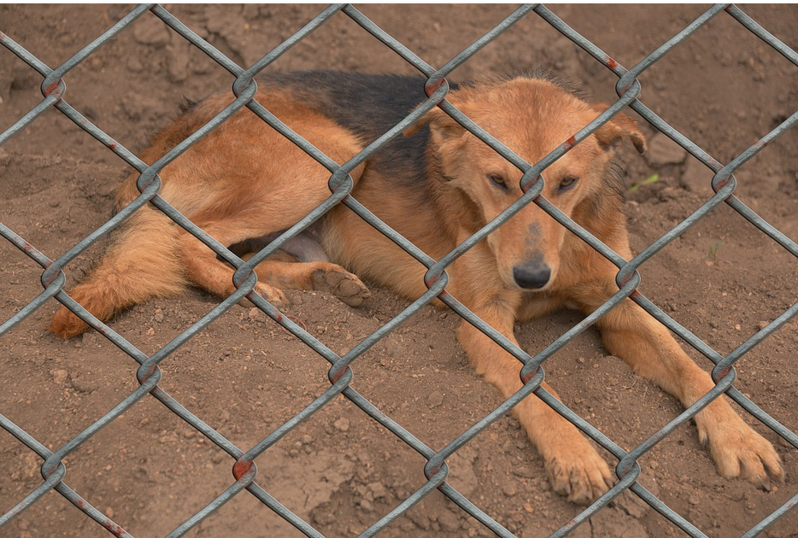
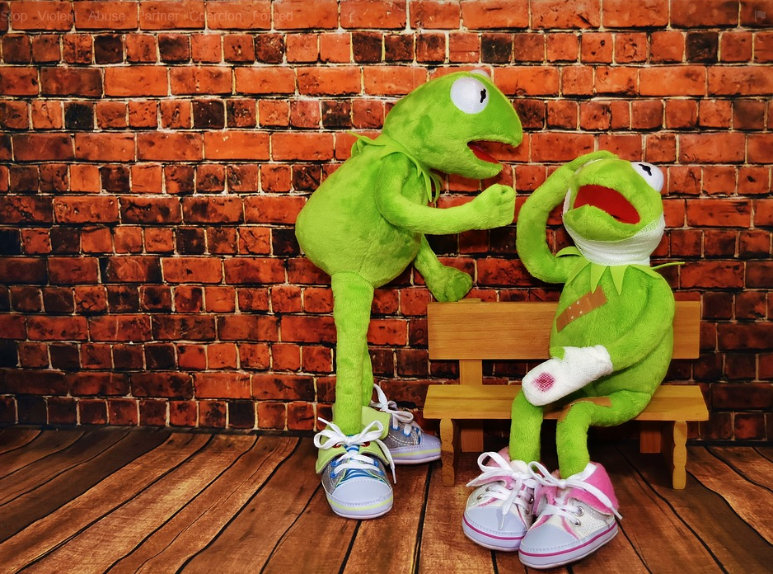
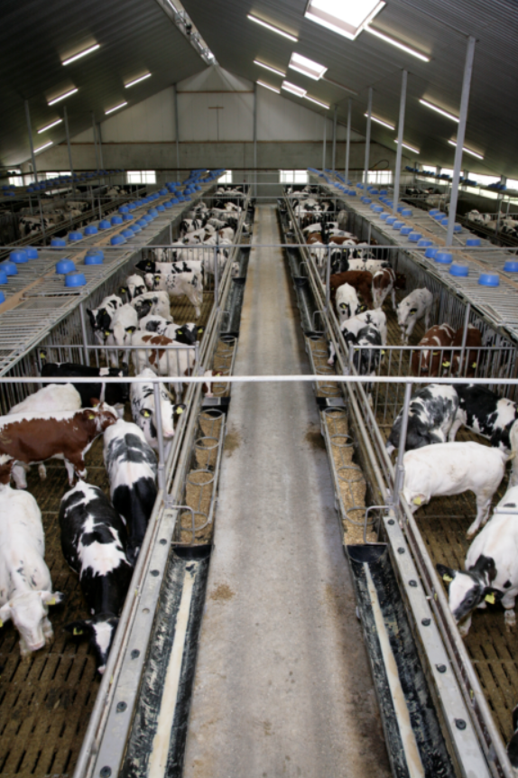
6.
8.
Courtesy of compassion in world farming

9.
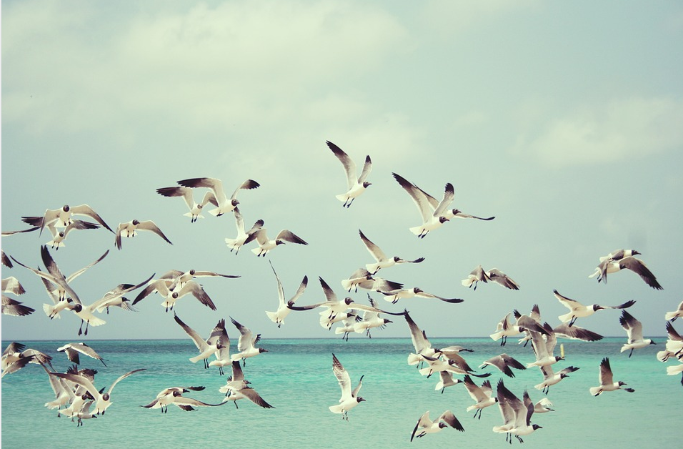

2,5,7,8,9 : Pixabay www.pixabay.com

Further Reading

These exercises are based on examples discussed in chapter 8 of Ecolinguistics: language, ecology and the stories we live by (Arran Stibbe, 2015, Routledge).

Share what you discovered

If you would like to share insights you discovered through these exercises then you can register for the free online course Stories We Live By here: http://storiesweliveby.org.uk/register. You will then have access to discussion groups, pages you can edit, and can apply for a free certificate of completion.

References

Abram, D., 1996. The spell of the sensuous: perception and language in a more-than-human world. New York: Pantheon.
MA (2005), Millennium Ecosystem Assessment Synthesis Report. Available from http://www.millenniumassessment.org//en/Products.Synthesis.aspx

Data examples with a two letter and number tag (e.g., AG5) are from the Ecolinguistics Text Collection. Full references can be looked up by accessing the collection here (http://storiesweliveby.org.uk/references) and using the tag.

