EXERCISES
PART 3: Framings

These exercises accompany part 3 of The Stories We Live By: an online course in ecolinguistics.
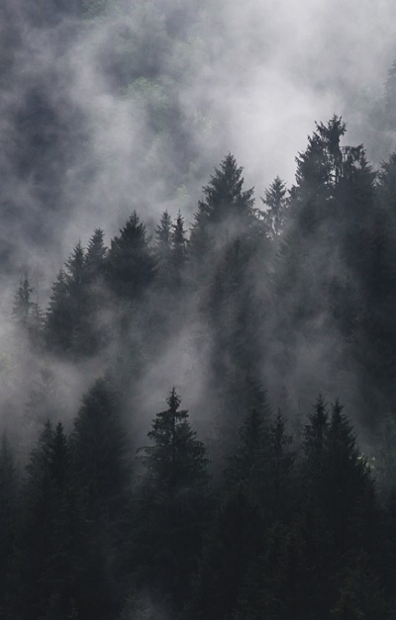
Exercise 1: framing of biodiversity

What actions are taken to preserve biodiversity depend on the framings used to understand exactly what biodiversity is. Below are some quotations which frame biodiversity in different ways (some are metaphorical framings and some literal). Firstly, discuss what actions the different framings might lead to, e.g., which species would be protected. Secondly, discuss the advantages and disadvantages of the framings in relation to your own ecosophy (e.g., your ecosophy might be focused on human wellbeing, respect and care for other species, general preservation of green spaces and wildlife, or protection of rare species).

Framing | 1. DATA: quotations about biodiversity
biodiversity is a web | Our planet is literally teeming with life. An amazing variety of habitats, people, plants, and animals—everything from penguins to peas and bacteria to buffalo—are all interconnected in a fragile web of life we call “biodiversity.” (Field 2008)
biodiversity is a resource | Every country and region has three forms of wealth: material, cultural and biological (biodiversity) (Miller 1999:11)  The global stocks of biological diversity generate a flow of services… (Wood et al 2000:1)  [Biodiversity is] a depletable endowment from the evolutionary process (ibid:7)  Britain is a biodiversity superpower squandering its species faster than almost any country on the planet (Pearce 2007)
biodiversity is a library | Innumerable potential new foods, drugs and useful products may yet be discovered—if we do not burn down the library first… In fact, the very basis of our civilization—our crops, domestic animals and many of our medicines and industrial products—have been derived from the planet’s vast genetic library. (Ehrlich 1992:12)
biodiversity is an illness | The scale of the crisis is so daunting that conservationists widely accept the need for some sort of triage, where limited funds go to the places where the greatest good can be done (Kareiva and Marvier 2003).
biodiversity is a service | Extinction in the wild ‘is danger to humans’. Scientists have discovered that the high level of extinction among wild species is making human life more precarious than thought. Humans rely on... “ecosystem services”: fresh water comes from forest-covered mountains...Losing wildlife, or biodiversity, means pushing these [ecosystem services] systems closer to collapse. (Highfield 2007)
biodiversity is heritage | The diversity of nature is as much part of our heritage as paintings and buildings. It may not be our own creation, but it is an essential part of the world that nurtures us and makes us human. We quite rightly go to great lengths to preserve the Pantheon and the Mona Lisa. (Papineau 1992:7:1)
biodiversity loss is apocalypse | The earth is losing species at a rate unparalleled in human experience…We biologists, alarmed at this imminent ecological Armageddon, have been increasingly casting ourselves in a Paul Revere mode, trying as best we can to raise the alarm to our fellow citizens. (Radford 1995: 8)
biodiversity is rare species | The problem conservationists face is this: that by comparison to almost all other global issues, our concerns about biodiversity seem effete and self-indulgent. If we are presented with a choice between growing food to avert starvation and protecting an obscure forest frog, the frog loses every time. If climate change is going to make life impossible for hundreds of millions of human beings, who cares about what it might do to Boyd’s forest dragon? (Monbiot 2004a)

Finally, analyse a selection of the framings in terms of trigger words, source frame, target domain, mappings and entailments. Does more detailed linguistic analysis help reveal something useful about the framings?

Exercise 2: predicaments vs problems

John Michael Greer made the interesting observation that:

Many things we’ve conceptualised as problems are actually predicaments... The difference is that a problem calls for a solution; the only question is whether one can be found and made to work, and once this is done, the problem is solved. A predicament, by contrast, has no solution. Faced with a predicament, people come up with responses (EN6:22).

Read the quotes below and discuss the advantages and disadvantages of framing ecological issues as ‘predicaments’ vs ‘problems’. Consider biodiversity, climate change, air pollution, peak oil, nature deficit disorder and other issues.

2. DATA – problem and predicament framings
The problem is simple. If we are to hold the rise in global temperatures to 2C above pre-industrial levels – the point at which global damage becomes potentially catastrophic – we have to stop increasing our carbon emissions by the end of this decade, and then reduce them (EN4).
The best solution, nearly all scientists agree, would be the simplest: stop burning fossil fuels, which would reduce the amount of carbon we dump into the atmosphere (EN5).
Peak oil is an opportunity to pause, to think through our present course, and to adjust to a saner path for the future. We had best face facts: we really have no choice. Peak oil is a horrible predicament. It is also a wonderful opportunity to do a lot better. Let's not squander this moment (EN7:197).
What to look for:

What trigger words show that a frame is being used?

What is the source frame and target domain?

What entailments does the framing lead to?

What stories do these entailments tell about the world?

Are the stories beneficial or destructive (judged according to your ecosophy)?

If the story is destructive, then what new framings would be more beneficial?

Exercise 3: commercial framings

Blackmore and Holmes (2013, p. 15) describe the Transactional Frame, where environmental issues are represented in terms of buying and selling:

We were told we could ‘save nature’ while we shopped, and offered 10% discounts as if the natural world were any other consumer good. We were even called ‘valued customers’ outright. The Transactional frame presented conservation organisations as a business, selling a product (conservation) to a customer (members or the public).

Consider the example below and discuss the advantages and disadvantages of using framings that centre around money.

3. DATA – commercial framings
[from Cred, a carbon reduction initiative] No cost, just savings! Just unplugging things when you’re not using them can help us reach the CRed 60% challenge ...Fit low energy bulbs where you can. For an initial outlay of just £7 for each bulb you will save about 80kg CO2 and £10 on your electricity bill ... Remember if it reduces the energy you need it will reduce the CO2 that you are responsible for and it will also make you richer. Just imagine what you could treat yourself to with all that money you won’t be spending on your energy! (EN3).

Exercise 4: framing sustainability

On the next page are quotations from a wide range of political sources which frame ‘development’, ‘sustainability’ and ‘sustainable development’ in a variety of ways. Draw a brain storm diagram (which can be as messy as you like) which illustrates how these framings relate to each other. Use concepts such as source frame, target domain, mapping, entailments, frame chaining, and frame displacement to link the different framings. Below is a diagram which illustrates some of the themes that appear in the quotes (with gratitude to Chris Seeley for drawing it).
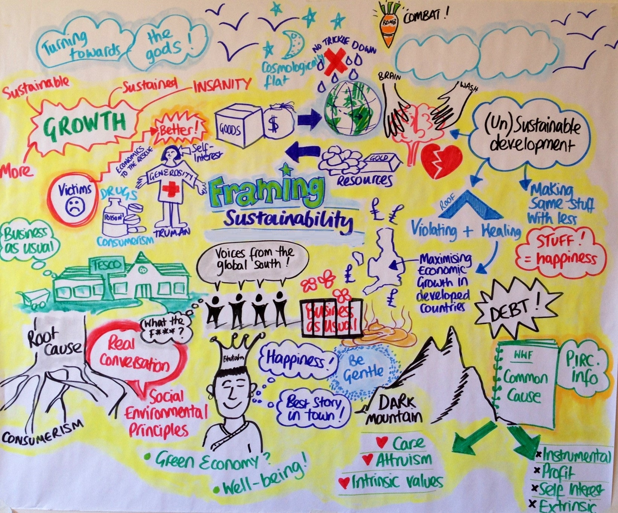

4: Data: quotes from various sources about development/sustainability
[The first use of ‘development’ was by missionaries in early 1940s, to replace the frame ‘uncivilised’]. It was no longer that Africans were ‘uncivilised’. Instead, they were ‘underdeveloped’. Either way, the ‘civilised’ or ‘developed’ European has a role to play in ‘civilizing’ or ‘developing’ Africa. (Manji and O’Coill 2002)
[President Truman first talks of ‘underdeveloped countries’ in 1949] We must embark on a bold new program for making the benefits of our scientific advances and industrial progress available for the improvement and growth of underdeveloped areas. More than half the people of the world are living in conditions approaching misery. Their food is inadequate. They are victims of disease…With the cooperation of business, private capital, agriculture, and labour in this country, this program can greatly increase the industrial activity in other nations… The old imperialism—exploitation for foreign profit—has no place in our plans (President Truman 1949 in Sachs 2000)
Clothing self-interest in generosity, Truman outlined a programme of technical assistance designed to ‘relieve the suffering of these peoples’ through ‘industrial activities’ and a ‘higher standard of living’ (Sachs 2000:3 commenting on Truman)
[but ‘development’ led to inequality] To be sure, ‘development’ had many effects, but one of the most insidious was the dissolution of cultures that were not built around a frenzy of accumulation (Sachs 2009:29). Conventional development can be regarded as a form of plunder. The Third World has been developed into a state whereby its land and labour benefit the rich, not Third World people. (Trainer 2011)
[therefore the frame was changed to ‘equitable development’] Every time in the last 30 years when the destructive effects of development were recognised the concept was stretched in such a way as to include both injury and therapy. For example, when it became obvious that the pursuit of development actually intensified poverty, the notion of ‘equitable development’ was invented so as to reconcile the irreconcilable: the creation of poverty with the abolition of poverty. (Sachs 2009:28)
[but ‘equitable’ development destroyed nature] The Brundtland Report incorporated concern for the environment into the concept of development by erecting ‘sustainable development’ as the conceptual roof for both violating and healing the environment... (Sachs 2009:28)
Sustainable development involves more than growth. It requires a change in the content of growth, to make it less material- and energy-intensive and more equitable in its impact. (Brundtland 1986, the first key definition, PD2)
[the World Bank has a slightly different framing] Inclusive green growth is the pathway to sustainable development. It is the only way to reconcile the rapid growth required to bring developing countries to the level of prosperity to which they aspire, meet the needs of the more than 1 billion people still living in poverty, and fulfil the global imperative of a better environment. (PD3)
[the UK Government takes ‘sustainable development’ and applies it to the UK, an already rich country] The government is committed to sustainable development. This means making the necessary decisions now to realise our vision of stimulating economic growth and tackling the deficit, maximising wellbeing and protecting our environment, without affecting the ability of future generations to do the same. (UK Govt 2011)
[then twists it to ‘sustainable growth’] The UK Government is committed to sustainable growth, economically and environmentally, and they see many opportunities for UK businesses in moving to a green economy…Government will seek to maximise economic growth, whilst decoupling it from impacts on the environment (UK Govt, PD4)
[sustainable development to ‘sustained economic growth’] With many key natural resources and ecosystems services scarce or under pressure, achieving sustained economic growth will require absolute decoupling of the production of goods and services from their environmental impacts (PD5)
[sustained growth to international competition] The UK faces a range of challenges as it seeks to return to sustained growth…the UK’s long term prospects will continue to be affected by ongoing fundamental shifts in the global economy, driven in part by increasing competition from rapidly industrialising economies (PD6)
[a radical alternative, ‘sustainable retreat’] we need most of all to renew that love and empathy that we lost when we began our love affair with city life… our goal should be the cessation of fossil-fuel as quickly as possible and there should be no more natural habitat destruction anywhere (Lovelock 2006).

Further Reading

These exercises are based on examples discussed in chapter 3 of Ecolinguistics: language, ecology and the stories we live by (Arran Stibbe, 2015, Routledge), and chapter 6 of Animals Erased (Arran Stibbe 2012, Wesleyan University Press)

Share what you discovered

If you would like to share insights you discovered through these exercises then you can register for the free online course Stories We Live By here: http://storiesweliveby.org.uk/register. You will then have access to discussion groups, pages you can edit, and can apply for a free certificate of completion.

References

Ehrlich, P. R. 1992. Environmental deterioration, biodiversity and the preservation of civilization. Environmentalist 12 (1): 9-14. *
Field (2008) Biodiversity and conservation: the web of life, The Field Museum http://www.fieldmuseum.org/biodiversity/intro.html [no longer available]
Highfield, R. (2007) “Extinction in the wild is ‘danger to humans’”, Telegraph (12 July 2007)
Kareiva, P. and M. Marvier (2003) “Conserving biodiversity coldspots”, American Scientist 91, July/August, 344-351
Lovelock, J., 2006. The revenge of Gaia: earth’s climate in crisis and the fate of humanity. New York: Basic Books.
Manji, F. and O’Coill, C., 2002. The missionary position: NGOs and development in Africa. International Affairs, 78 (3), 567–583.
Miller, T. (1999) Environmental Science, London: Wadsworth
Monbiot, G. (2004a) “Natural Aesthetes” Guardian (13 January 2004)
Papineau, D. 1992. In the footsteps of the dodo. Book review of E. O.Wilson’s The Diversity of Life. The New York Times, 4 October, p. 7:1. *
Pearce, F. (2007) “Britain fails to protect its overseas biodiversity”, Telegraph (03 October 2007)
Radford, T. 1995. World losing three species every hour. The Guardian, 18 February, p. 8. *
Sachs, Wolfgang (2000) Planet Dialectic: explorations in environment and development. London: Zed books
Sachs, Wolfgang (2009) The development dictionary. Second edition. London: Zed books
Stibbe, Arran (2009) The handbook of sustainability literacy. Dartington: Green Books
Trainer, Ted (2011) The Simpler Way perspective on the global predicament. Energy Bulletin http://www.energybulletin.net/stories/2011-05-31/simpler-way-perspective-global-predicament
UK Government (2011) Mainstreaming sustainable development. http://sd.defra.gov.uk/gov/vision/
Väliverronen, E. and Hellsten, I., 2002. From ‘burning library’ to ‘green medicine’ the role of metaphors in communicating biodiversity. Science Communication, 24 (2), 229–245.
Wood, A. and P. Stedman-Edwards and J. Mang (eds) (2000) The root causes of biodiversity loss, London: Earthscan

Data examples with a two letter and number tag (e.g., AG5) are from the Ecolinguistics Text Collection. Full references can be looked up by accessing the collection here (http://storiesweliveby.org.uk/references) and using the tag.

* These examples are from Väliverronen and Hellsten (2002)

